|  |  |
| --- | --- |
| Fujifilm GF 32-64mm f/4 R LM WR lens  Ống kính Fujifilm GF 32-64mm f/4 R LM WR | Chính hãng  FUJIFILM GF 32-64mm f4 R LM WR  Chính hãng FUJIFILM GF 32-64mm f4 R LM WR  Chính hãng.1 FUJIFILM GF 32-64mm f4 R LM WR  Chính hãng.5 FUJIFILM GF 32-64mm f4 R LM WR  Chính hãng.4 | **Featured information:**  Anti-vibration: No  Aperture: F4-32  Closest focusing distance: 50mm  Filter size: 77mm  Price : $ 2000  **Specifications:**  Focal distance  32 - 64mm  Largest Aperture  f/4  Smallest Aperture  f/32  Lens Mount  FUJIFILM G  Lens Format  N/A  View  46.3° - 81°  Minimum Focus Distance  50 cm  Magnification  0.12x  Optical Components  14 Elements in 11 Groups  Number of Mouth Blades  9  Focus Type  Autofocus  Anti-Vibration  No |

**Overview:**

FUJIFILM GF 32-64mm f/4 R LM WR is a wide-angle zoom lens, suitable for everyday photography, helping to preserve life's moments. Possessing optimal optical design, quick focusing ability and strong weather resistance, this Lens has become the choice of many photography lovers.

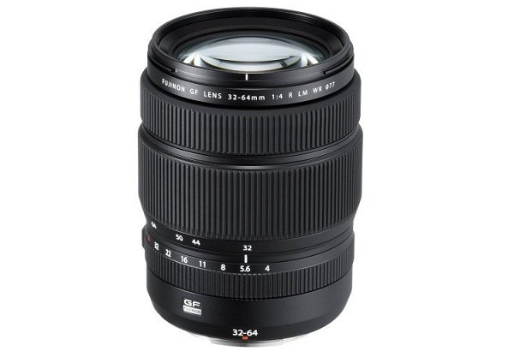

FUJIFILM GF 32-64mm f/4 R LM WR belongs to Fujifilm's G-mount medium format lens line, providing a 25-51mm equivalent focal length allowing photography of many genres, in many different situations.

Constant f/4 maximum aperture provides consistent shooting performance throughout the entire zoom range, resulting in images that are always bright and noise-free in dark conditions.

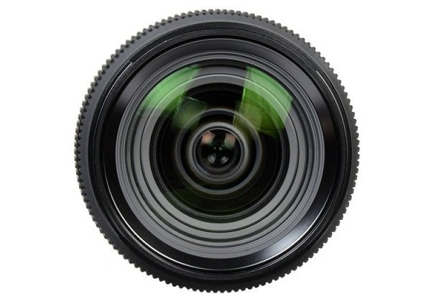

The lens has an optical structure of 14 elements divided into 11 groups, including three aspherical elements that help control spherical aberration and distortion, bringing greater sharpness and accuracy to the frame. In addition, the lens also has an ED lens and a Super ED lens to help minimize chromatic aberrations, color fringing, increase color contrast, for vivid and vivid images. more honest.

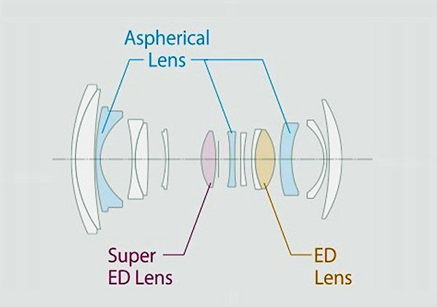

Integrating an internal focusing mechanism with a linear autofocus motor, the lens provides fast, smooth, and silent focusing performance, helping users capture every moment of life and preserve it. with quality frames and footage.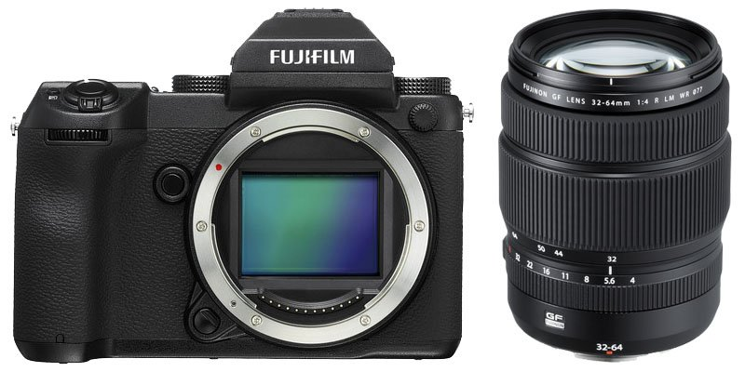

The front and rear lenses of the FUJIFILM GF 32-64mm f/4 R LM WR are coated with a Fluorine protective layer to help prevent moisture, limiting mold and mildew causing damage or affecting the camera's ability to operate.